**Group Assignment 1**

**Yashwanth Mujakari**

**Naveenbabu Chejarla**

**Object Oriented Development**

**April 6, 2024**

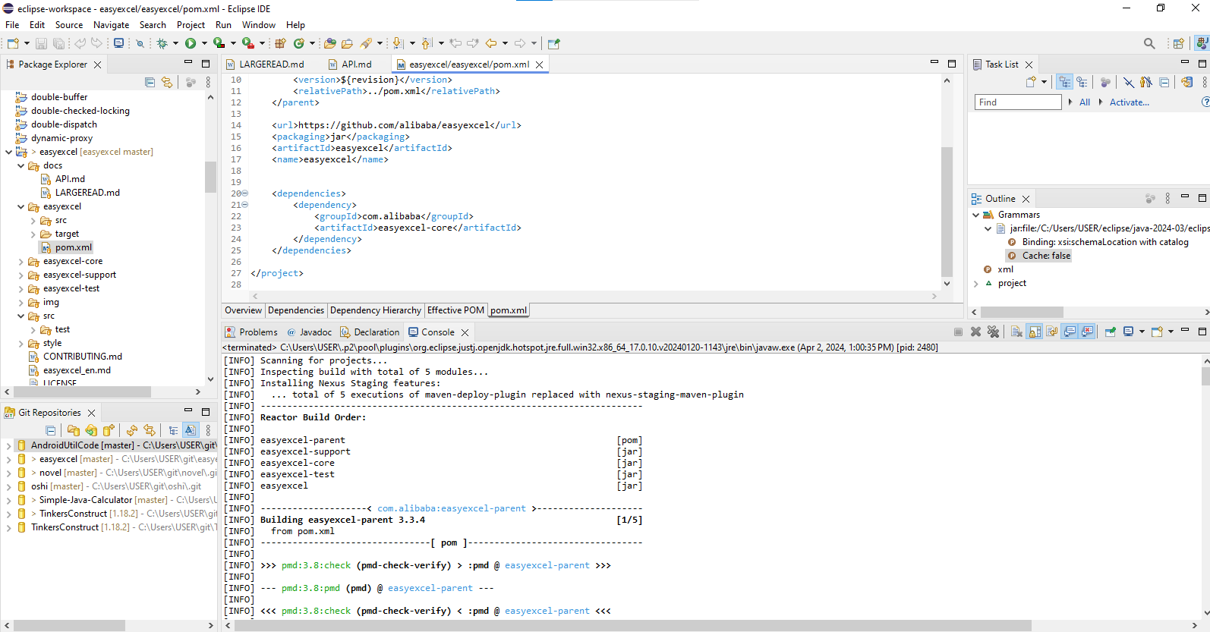

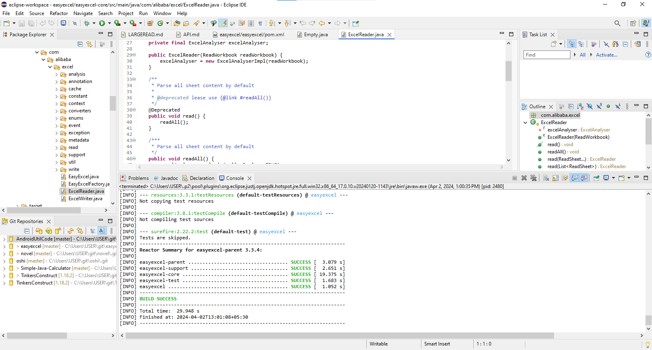

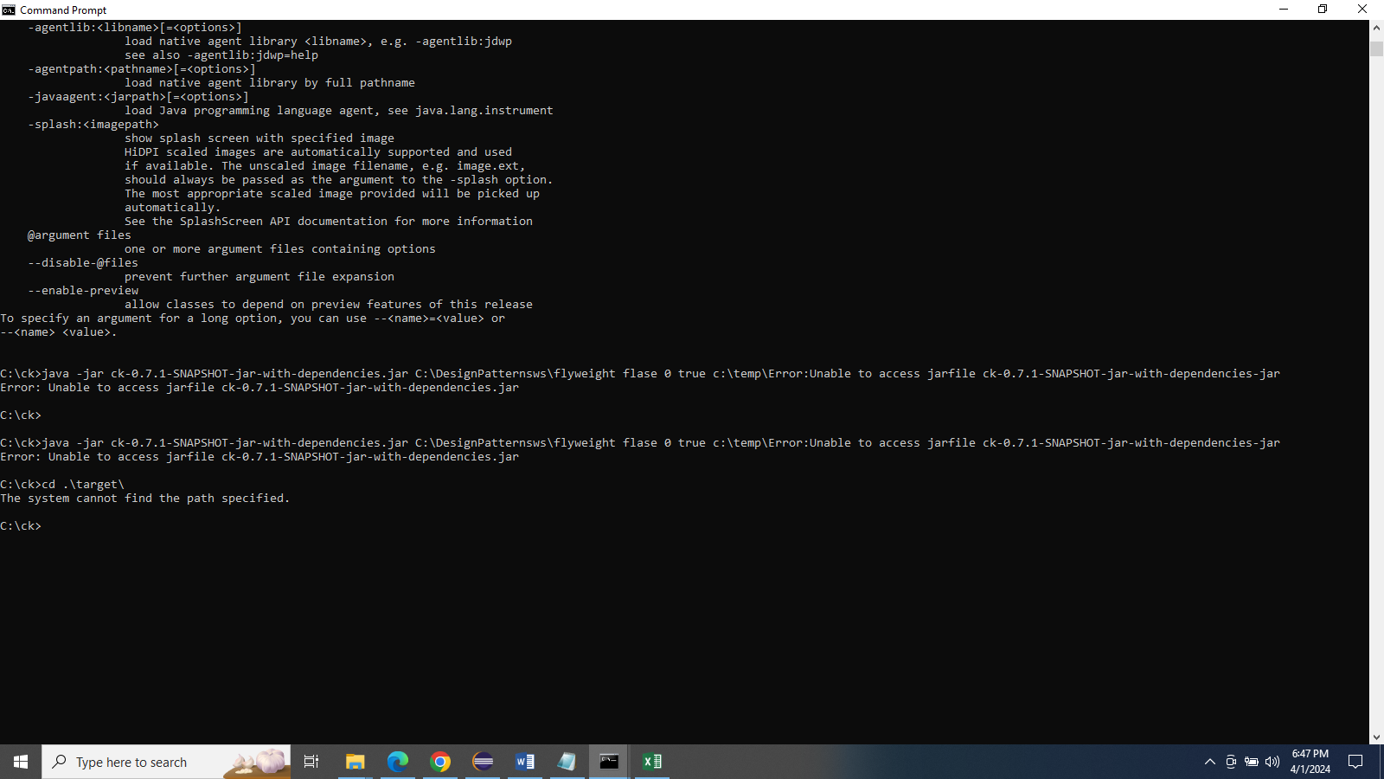

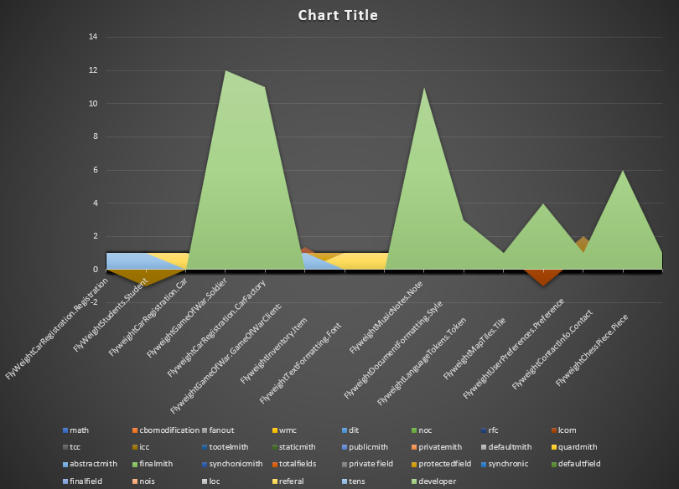

1. https://github.com/alibaba/easyexcel

2. <https://github.com/doocs/advanced-java>

3. <https://github.com/Blankj/AndroidUtilCode>

4. <https://github.com/Snailclimb/JavaGuide>

5. <https://github.com/201206030/novel>

The labels filled in, the provided line graph depicts the relative memory consumption of different Java operations when processing Excel files using different libraries. It suggests that these procedures are especially memory-intensive because it displays discrete peaks at "statcmith" and "token". From a translational perspective, these peaks could represent the high memory demands of conventional libraries like Apache POI, while the general trend of the graph could show how the optimized library, easyexcel, improves efficiency and reduces memory footprint. This is particularly true when working with bigger Excel files, as easyexcel avoids memory overflow.

The project's material is mainly taken from Zhonghua Shishan and covers important topics like distributed systems, microservices, and high concurrency. It's all neatly packed for simple reference. Doocs and Leetcode are examples of actively updated algorithmic tools; this is important for interviewees practicing their coding abilities. Although it lacks a title and context, the chart implies a data-driven approach to understanding these complex topics. It could map out the frequency or performance of different programming constructs or practices within the scope of advanced Java applications. The platform encourages developers to engage in the Discussions area, sharing insights and practical experiences.

The picture shows a complicated area graph with many peaks and valleys, which stand for the usage or significance of numerous AndroidUtilCode library components. Different peaks indicate different levels of complexity or frequency of use; for example, 'utilcode' and'subutil' relate to different library modules or functions. Various colors on the graph indicate different categories, which may represent various library utilities or methods. The most significant or often utilized module is indicated by the tallest peak. A more descriptive title and axis labels would have helped put the data displayed in perspective, such as the frequency of usage of each utility or the complexity grade, but these are absent from the chart. The overarching goal of the graph is to show how the various functions of the AndroidUtilCode library are used, whether that's to see which ones are most and least used, or which ones are most important for making Android development faster and easier.

The picture is a bar chart showing different software-related things on the x-axis, which probably stand for different parts of a code structure. Some categories show very few or no occurrences, while others have prominent peaks that indicate very high values or occurrences. Various data kinds or classes could be represented by using different bar colors. In the translated Chinese text mentioning Apache POI and jxl frameworks, there are concerns regarding memory intensity; this matches with the general pattern of the chart, which lacks a distinct title but suggests a disparity in the distribution of a metric, maybe memory utilization.

The given chart shows a diverse dataset that could represent various parts of a Java-based novel project. It shows areas of high engagement, like novel recommendations or comments, and areas of low interaction, like system features like memory usage (a known issue in Java frameworks like Apache POI and JXL), with peaks and troughs, respectively. Developers of all-inclusive Java systems, including those for backend management and user interface, could benefit from using this graph as an analytical tool to see how resources are being allocated, how popular features are, and how well the system is performing overall.

**Conclusion**

Without more information, the line graph may be interpreted as an assessment of memory usage for different actions when viewed through the lens of Java-based systems that deal with Excel files. According to the Chinese text, libraries like Apache POI and JXL may be inefficient, since there are noticeable peaks at operations like "statcmith" and "token" that suggest excessive memory utilization. One possible interpretation of the graph is that it shows how using efficient solutions, such the easyexcel package, can help reduce memory overflow problems in huge Excel files. Despite the data pointing to an improvement in Java application processing efficiency, more context and labeling is clearly needed to comprehend the graph's effects on Java system performance, especially in demanding environments with high concurrency and distributed systems. Reflecting a larger trend in the growth of Java development techniques, the visualization highlights the significance of resource management in complex Java projects and the community's continual efforts to improve performance and optimize memory usage.